Ancient Civilization Unit
For all stations make sure to provide a list of your sources.
Station 1
Timeline
Create a detailed and illustrated (drawings or pictures), timeline for your chosen Ancient Civilization. Must have 10-15 key points. Can be on paper or digital.
Timeline sources:
https://www.wikihow.com/Make-a-Timeline
http://www.readwritethink.org/files/resources/interactives/timeline_2/
https://support.office.com/en-us/article/Create-a-timeline-9c4448a9-99c7-4b0e-8eff-0dcf535f223c
https://www.officetimeline.com/excel-timeline
Station 2
Famous people
Chose six famous people from your civilization and write a paragraph or point form notes highlighting roles, accomplishments, interesting facts, etc. Use template or word document. Include a drawing or photo of the person.
Station 3
Social order
Research and take notes on your civilizations social order. Use a minimum of six roles. Use template provided. Drawing and written description must be done for each role.
-Describe in your own words the positions of society and importance of each.
-Duties held by each are mentioned and explained.
Station 4
Decline and Fall
Explain the decline and fall of your Ancient Civilization. Use the provided resource to research this station. Take notes in OneNote or a duo-tang. Give a thorough explanation using Comic Life or a Story Board.
Resources
http://gss.sd42.libguides.com/c.php?g=698159&p=4961550
Comic Life
http://www.storyboardthat.com/
Station 5
Agriculture
Research agriculture in your civilization. Use provided template to record a year account of agricultural practices. Describe planting, harvesting, crops, jobs (who did the work), pruning, sowing, etc.
Possible resources
http://www.historyforkids.net/ancient-chinese-daily-life.html
http://factsanddetails.com/china/cat2/4sub7/entry-5413.html
http://www.chinasage.info/rice.htm

Handouts
Station 6
Religion – God/Goddess or Death Practices
Find a photo and get it to your teacher to be printed and enlarged. Trace and colour one of the gods from your civilization. As a challenge, draw your god free hand. Ensure that you use appropriate colours for the god you chose. Please complete the following about your god and include on your poster:
- What was this god’s job/purpose?
- Who were this god’s relatives (include how they were related, i.e. mother, sister, uncle, etc.)
- Create your own myth/short story about this god, minimum 200 words.
OR
Research the death practices of your ancient civilization provide hand drawn or traced picture(s) with a paragraph description (minimum 200 words). Your description should outline the steps involved in body preparation, special practices, rituals, prayers, and preparation for afterlife etc.
Station 7
Government
Create a flow chart outlining the government structure of your ancient civilization. Label title/roles with a brief description (note or paragraph format). Can be digital or on paper.
Resources
https://www.wikihow.com/Create-a-Flowchart
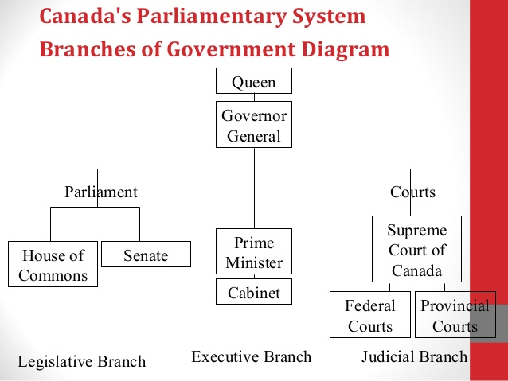
Station 8
Technology
Build/make an artefact demonstrating a technological advancement made by your civilization. Make sure to get approval by your teacher. No writing piece is required but you do need to do research and take notes to be able to explain your technology to visitors to our exhibit. YOU ARE EXPECTED TO BE AN EXPERT!
Examples
Egypt – Pyramid, Sphinx, irrigation, paper, hieroglyphics, mummification, etc.
Greece – Parthenon, catapult, water clock, water mill, Archimedes screw, etc.
Inca – Machu Picchu, Inca road, temples, quipus, water storage, suspension bridge, etc.
China – Great Wall, Grand Canal, Terra Cota warriors, Shaolin Temple, Forbidden City, Silk, Paper, Rockets, Gun Powder, Compass, Printing etc.
https://www.ducksters.com/history/china/inventions_technology.php

Station 9
Map
Complete the provided map – Learn more about your ancient civilization by labelling the map with the following:
- 10 ancient cities
- zones/city states/sections/districts
- major bodies of water – oceans, seas, lakes, rivers, mountains, deserts
- put in some of the surrounding modern day countries.
- important landmarks, structures, and locations (Parthenon, Machu Picchu, Pyramids, etc.)
- map features - title, legend and compass
- coloured

More China Links
SD42 Ancient Civilizations links http://gss.sd42.libguides.com/c.php?g=698159&p=4961550

Timeline Ancient China New Ancient China Timeline

Timeline http://timelineindex.com/content/search.php?s=china

Ancient China Website from Australia with lots of links: https://libguides.brisbanegrammar.com/yr7ancientchina

Animated history of China part 1 The Animated History of China | Part 1

Animated history part 2. The Animated History of China | Part 2
https://china.mrdonn.org/inventions.html

